Microsoft Word 2019 - Mail Merge
Mail merge is a tool which allows you to create form letters, mailing labels and envelopes by linking a main document to a data source. It is the process of combining a list of data with a template.

The mail merge process involves the following:
- The Main Document – contains the text and graphics that are the same for each version of the merged document.

- Data Source – a file that contains the information to be merged into a document. For example, the names and addresses of the recipients of a letter.

Mail Merge – Form Letters
  - Open Word and create a new blank document
  - Type the letter with all needed text and formatting, leaving room for the data from the data source (example: name, address, etc.)
  - Click the Mailings tab
  - Click Start Mail Merge

Click Step-by-Step Mail Merge Wizard
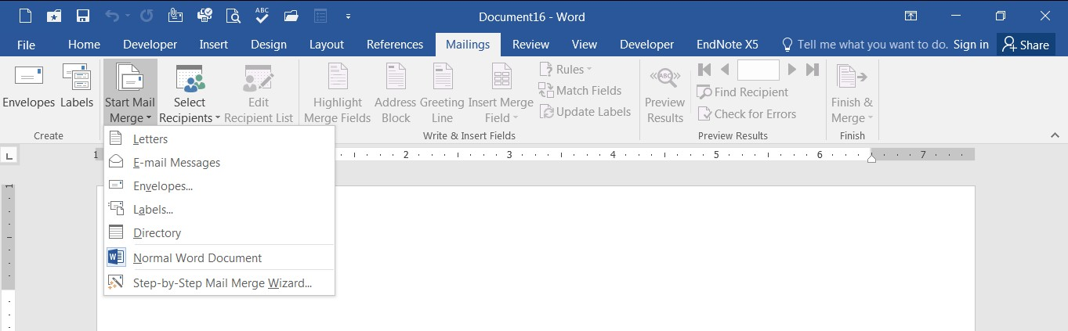

The Mail Merge task pane appears on the right of your screen. Note there are 6 steps.

Step 1 – Select Document Type
- Click Letters for the document type
- Click Next: Starting document

Step 2 – Select Starting Document
- Click Use the current document under Select starting document
- Click Next: Select recipients

Step 3 – Select Recipients
The recipients can come from either an existing Excel file, an Access table or you can create a new list in Word.

If Using an Existing List:
- Click Use an existing list under Select recipients
- Click Browse
- Select the file
- Click Open
- Select the worksheet tab name that contains the data
- Click OK (Mail Merge Recipients opens showing the file data)
- Click OK
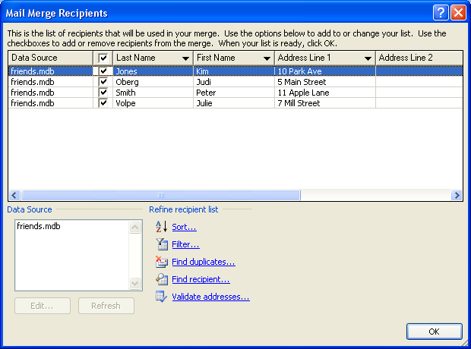

- Click Next: Write your letter

If Creating a New List:
- Click Type a new list under Select recipients
- Click Create
- Click Customize Columns to modify the list of fields

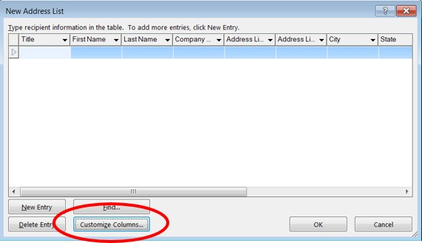

- Delete any unnecessary field names and/or add new ones
- Click OK
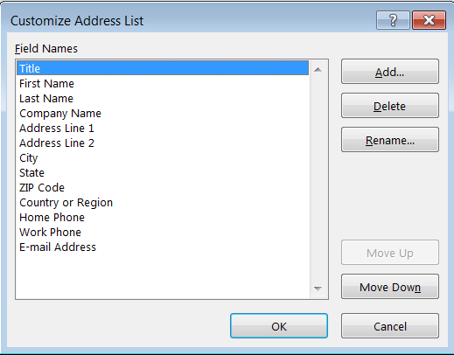

- Begin typing records, hitting TAB to advance to the next field and to continue adding new records
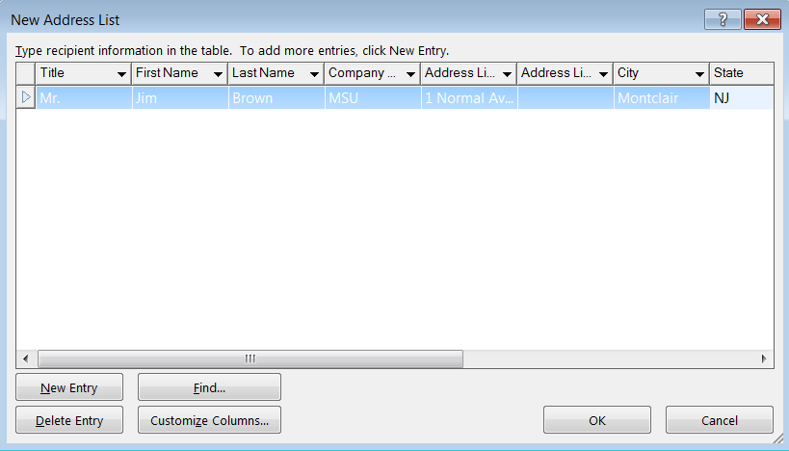

- Click OK
- Click Save

The recipients list will be saved as a separate file as a Microsoft Access file type. It is saved in the
My Data Sources folder. It is recommended to save the file in this folder.

- Click Next: Write your letter

Step 4 – Write Your Letter
- If including an address, click the location in your document where the address data will be inserted
- Click Address block…
- Select the address elements you want included
- Click OK
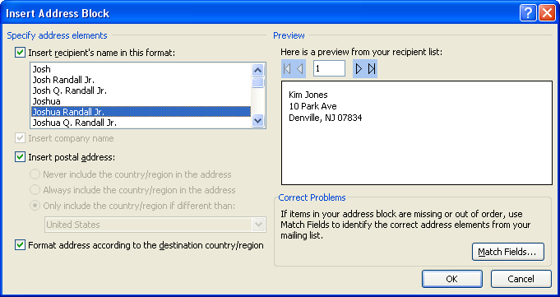

The field name will look like this: <<AddressBlock>>

The address block will insert the following fields including any necessary punctuation: First Name, Last Name, Company, Address 1, Address 2, City, State, Postal Code.

If your fields do not match the ones listed above or you are not using address fields, click More

items…
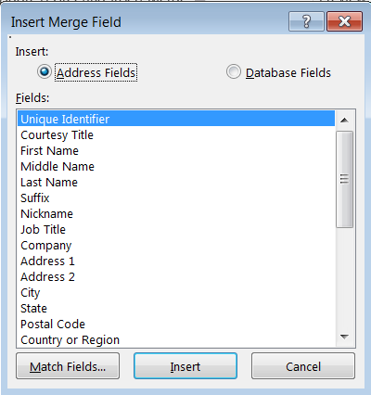

- Click on the field from the list
- Click Insert
- Click Close
The field name will look like this - «First_Name»
- Repeat this step until all fields have been inserted.
Remember to put spaces and punctuation where needed.

Click Next: Preview your letters

Step 5 – Preview Your Letters
Here is where you can preview the first page with the fields filled in.

Click Next: Complete the merge

Step 6 – Complete the Merge
- Click Print to send directly to the printer
- Click Edit individual letters to create a new file

Remember to save your document as you go. The next time you open your document and click on
Step-by-Step Mail Merge, the data source file will be attached.

Mail Merge – Labels
- Create a new blank document
- Click the Mailings tab
- Click Start Mail Merge

Click Step-by-Step Mail Merge Wizard

Step 1 – Select Document Type
- Click Labels for the document type
- Click Next: Starting document

Step 2 – Select Starting Document
- Click Use the current document
- Click Label options under Change document layout
- Choose the label style you are using
- Click OK
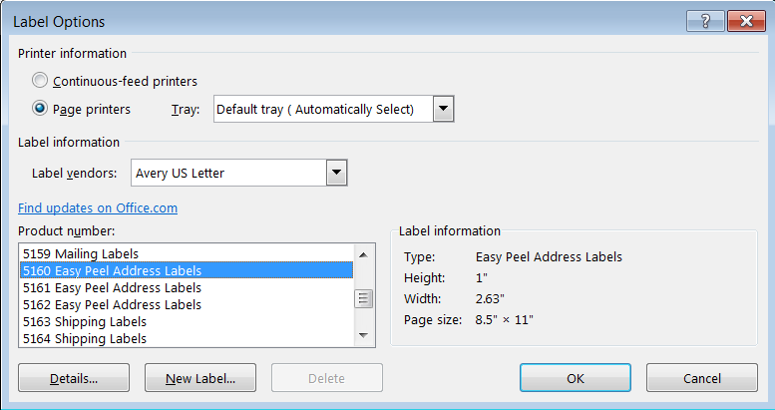

- Click Next: Select recipients

Step 3 – Select Recipients
- Click Use an existing list under Select recipients (or you can create a new list)
- Click Browse
- Select the file
- Click Open
- Select the worksheet tab name that contains the data
- Click OK

Click Next: Arrange your labels

Step 4 – Write Your Letter
- If including an address, click the location in your document where the address data will be inserted
- Click Address block…
- Select the address elements you want included
- Click OK

The field name will look like this: <<AddressBlock>>

The address block will insert the following fields including any necessary punctuation: First Name, Last Name, Company, Address 1, Address 2, City, State, Postal Code.

If your fields do not match the ones listed above or you are not using address fields, click More

items…

- Click on the field from the list
- Click Insert
- Click Close
The field name will look like this - «First_Name»
- Repeat this step until all fields have been inserted.
Remember to put spaces and punctuation where needed.
- Click Next: Preview your letters

